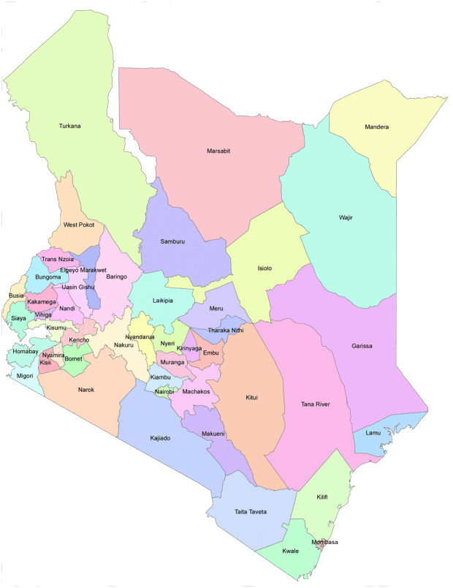

Wajir is a county in North East Kenya. It has borders with Somalia and Ethiopia. It is mainly a rural area, but has one large city called Wajir. The county of Wajir is huge – covering an area half the size of England.

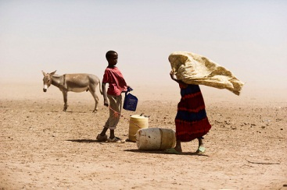

The counties of Wajir and Nairobi, Kenya

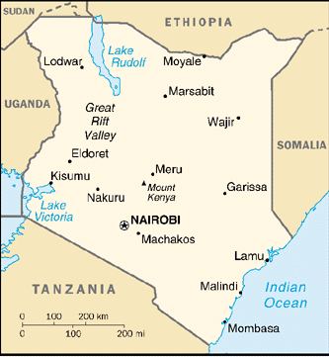

(Photo credits: Flickr US_AID, Flickr CC: Ollipikanen)

In the south of Kenya, Nairobi is the capital city and the largest city in Kenya with a population of over three million people. The whole county of Nairobi is urban – an area in km2 about the same as Manchester. Nairobi started out as a rail depot on the railway line linking Uganda with the port of Mombasa.

